# Dos Commands

MS-DOS stands for Microsoft Disk Operating System and is also known as Microsoft DOS. MS-DOS was the Microsoft-marketed version of the first operating system (OS) to be widely installed on personal computers (PCs). It was essentially the same OS that Bill Gates's young company developed for IBM as Personal Computer - Disk Operating System (PC-DOS). (Techtarget, n.d.)

## Date and Time:

TIME command is used to show or edit the system time whereas DATE command is used to display or edit the system date. (Computer Hope, n.d.)

Commands used:

1. **Date- To show or edit system date:**
2. 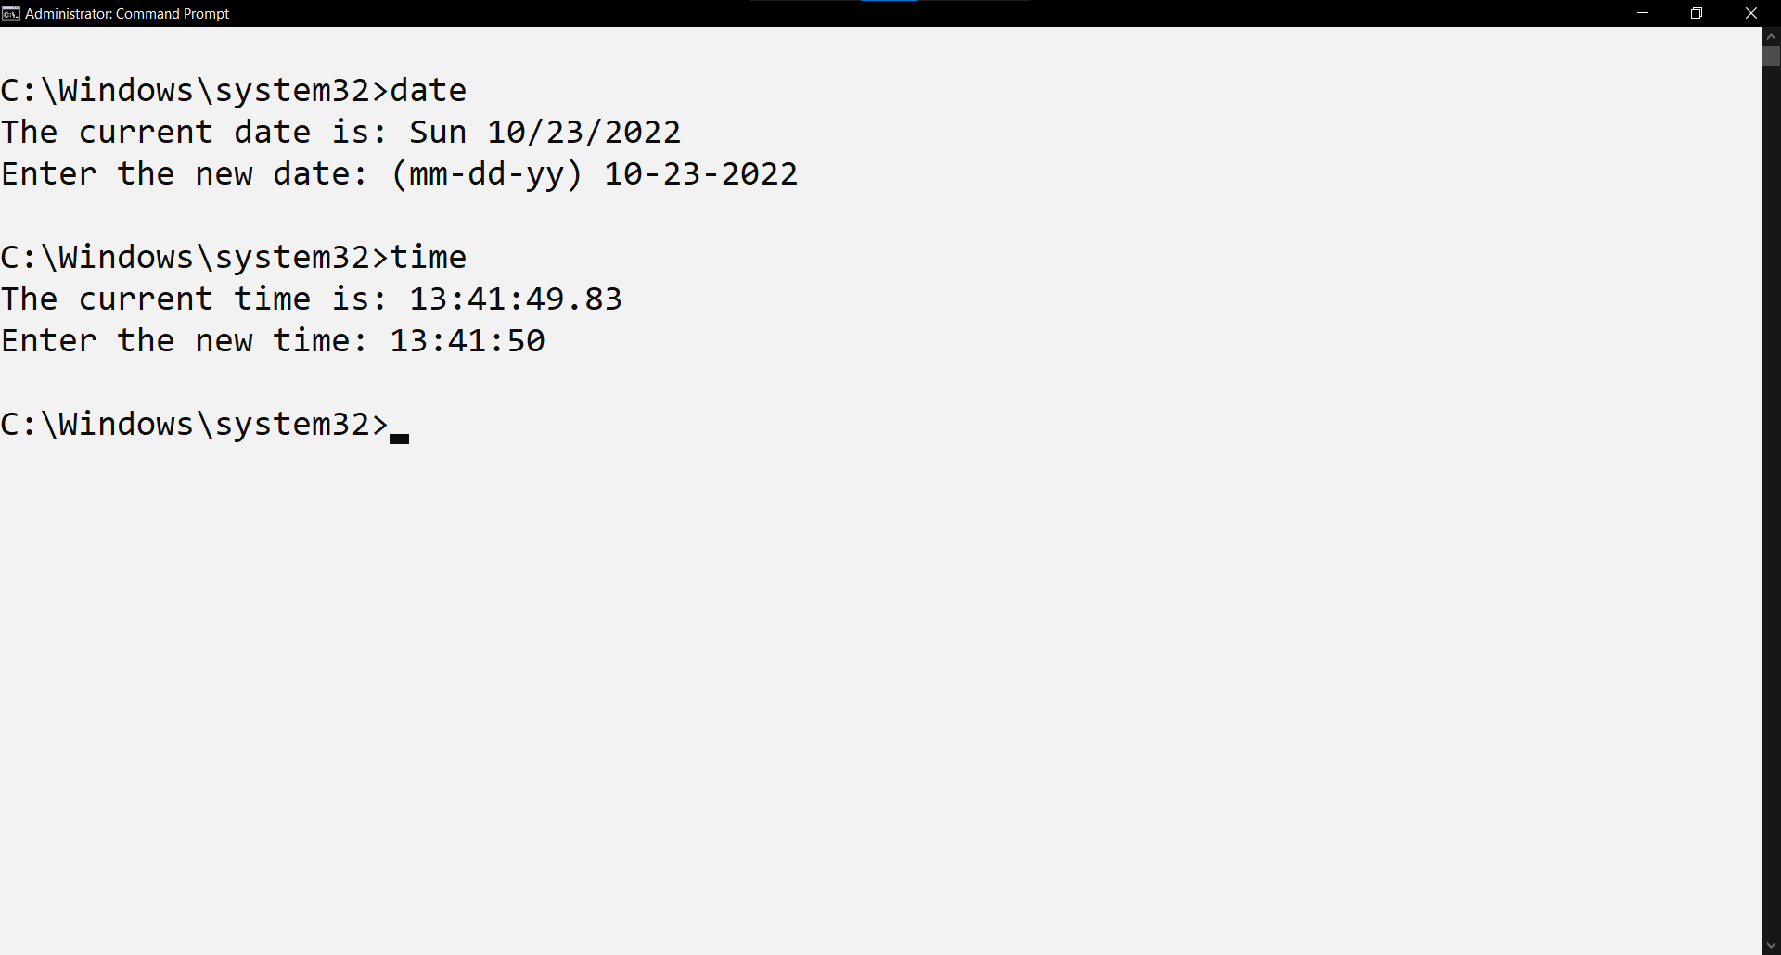**Time- To show or edit system time:**

## Cd:

Change Directory can be used to change the directory in which the command palette is currently opened in. ‘Cd’ is used to change directory in dos commands.

The syntax for change directory is:

Cd (path). Cd / can be used to go the start of the disk where are cd ../ can be used to move a step backward in the directory tree. Cd /d is used to change the disk in cmd. (Computer Hope, n.d.)

Command used:

1. **Cd – Used to change the directory of MS Dos window**.

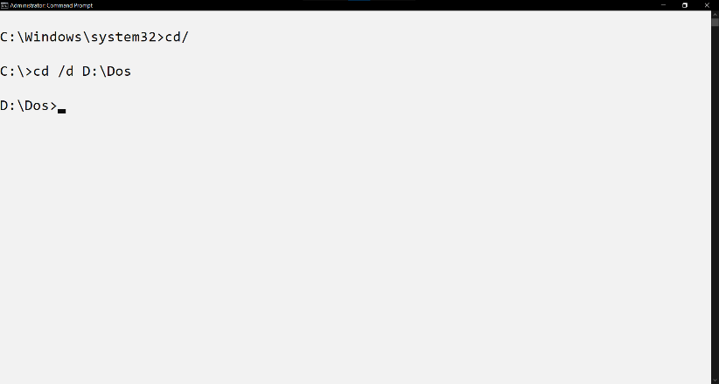

## Tree:

Tree is an external command, which graphically displays the path of each directory and sub-directories on the specified drive. The command is available in MS- DOS versions 3.2 and later. (Computer Hope, n.d.)

Command used:

1. **Tree- Show the directory tree.**

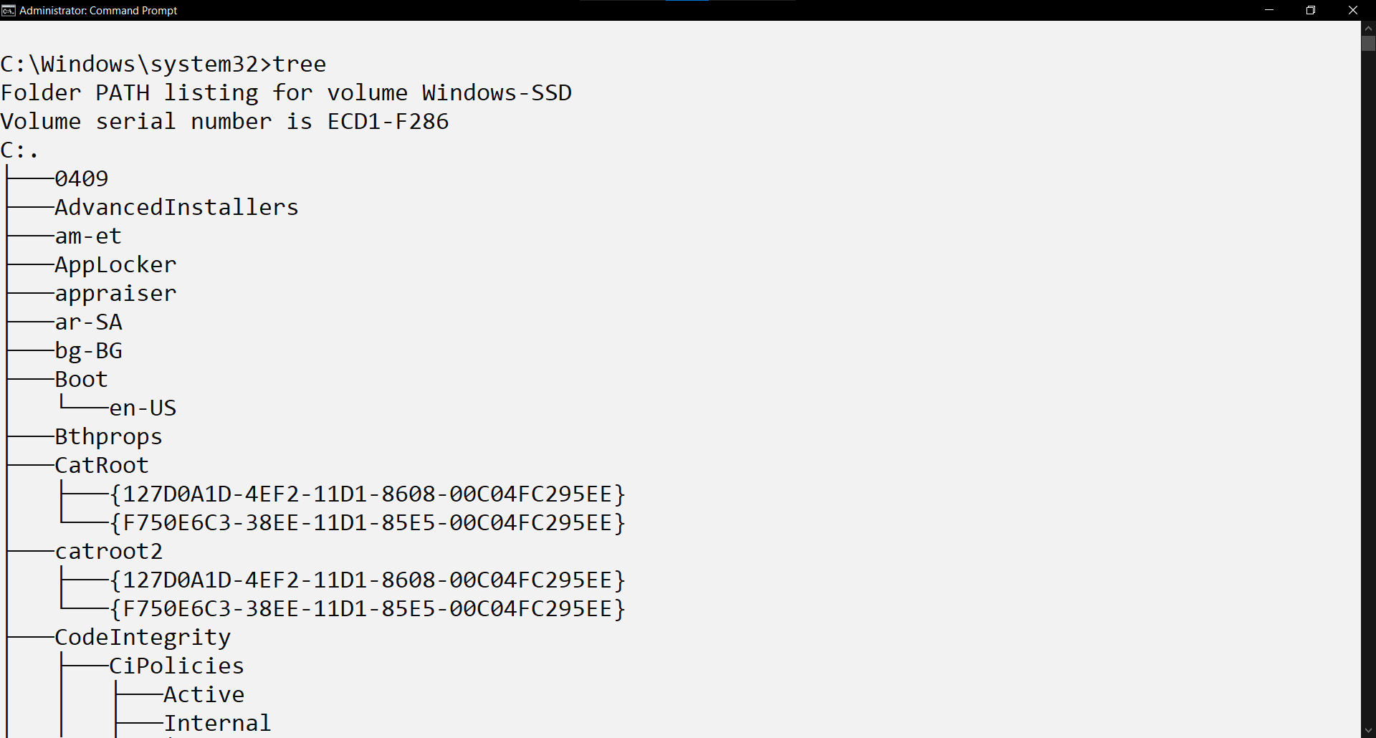

## Cls:

Cls is a command that is used to clear the screen in dos. It is available in MS- DOS versions 2 and later. (Computer Hope, n.d.)

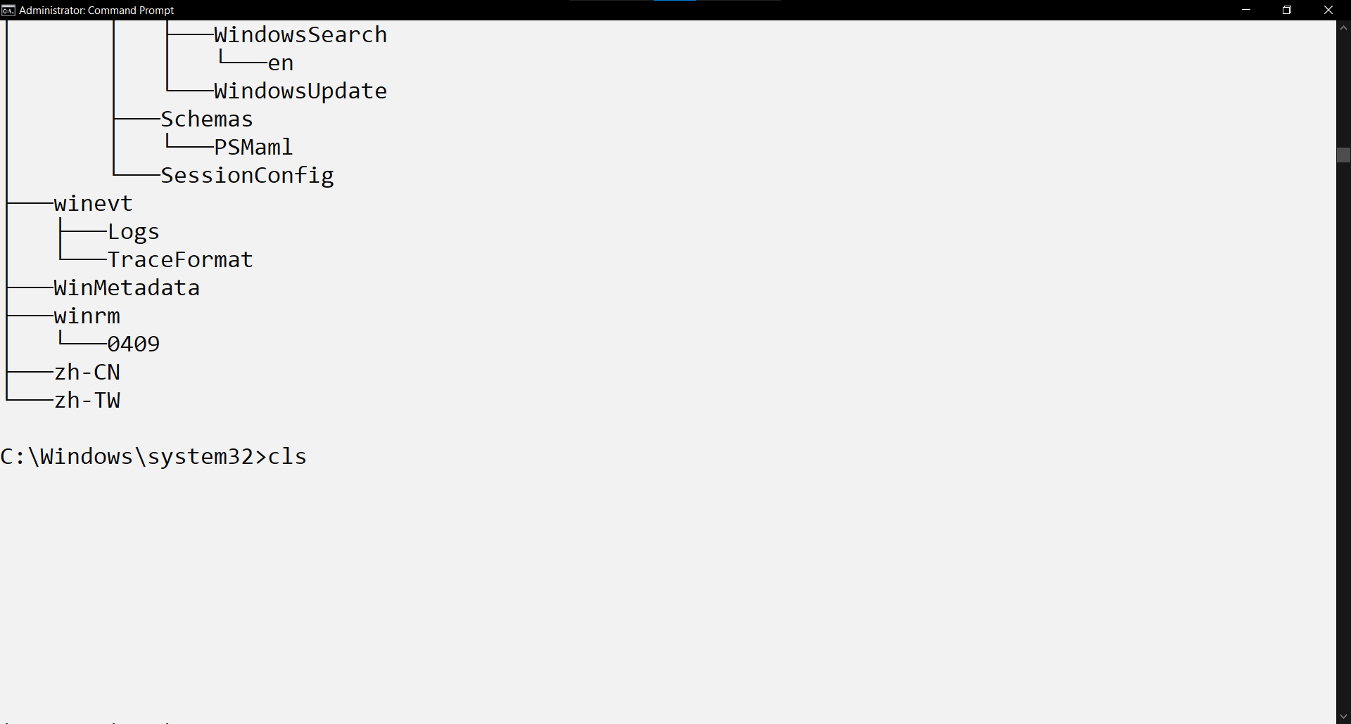Command used: **cls- Used to clear the MS Dos window.**

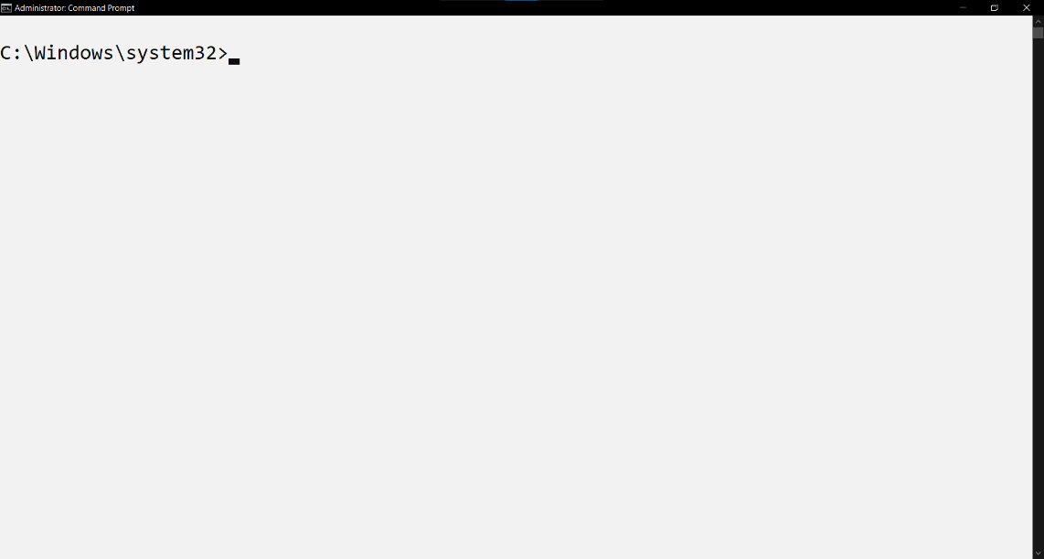

## Ver/Vol:

Vol is an internal command that is used to display the disk volume label along with the serial number. Ver is an internal command that is used to display the version of windows currently installed in the machine. The command was first seen in MS- DOS version 2. (Computer Hope, n.d.)

Command used:

1. **Vol- Shows the disk volume label along with the serial number.**
2. 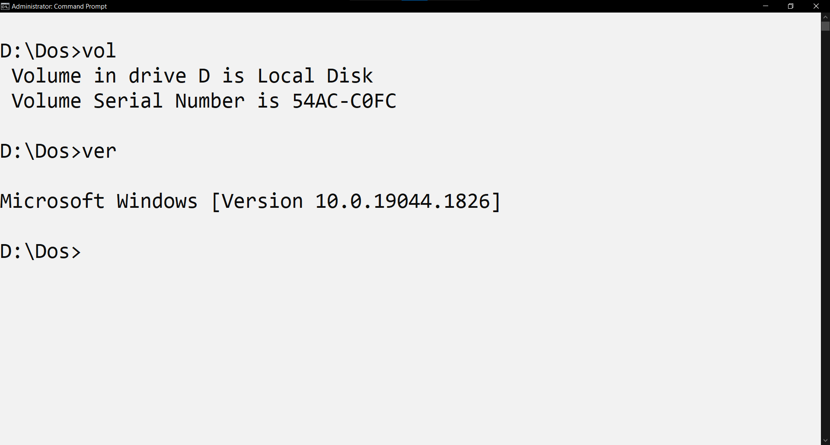**Ver- Shows the version of windows currently installed in the machine.**

## Md/Mkdir:

Md is a command used to create directory in Microsoft DOS. Mkdir is also used in DOS to create new directory. (Computer Hope, n.d.)

Command used:

1. **Md- To make directory.**
2. **Tree - To show the directory tree.**
3. 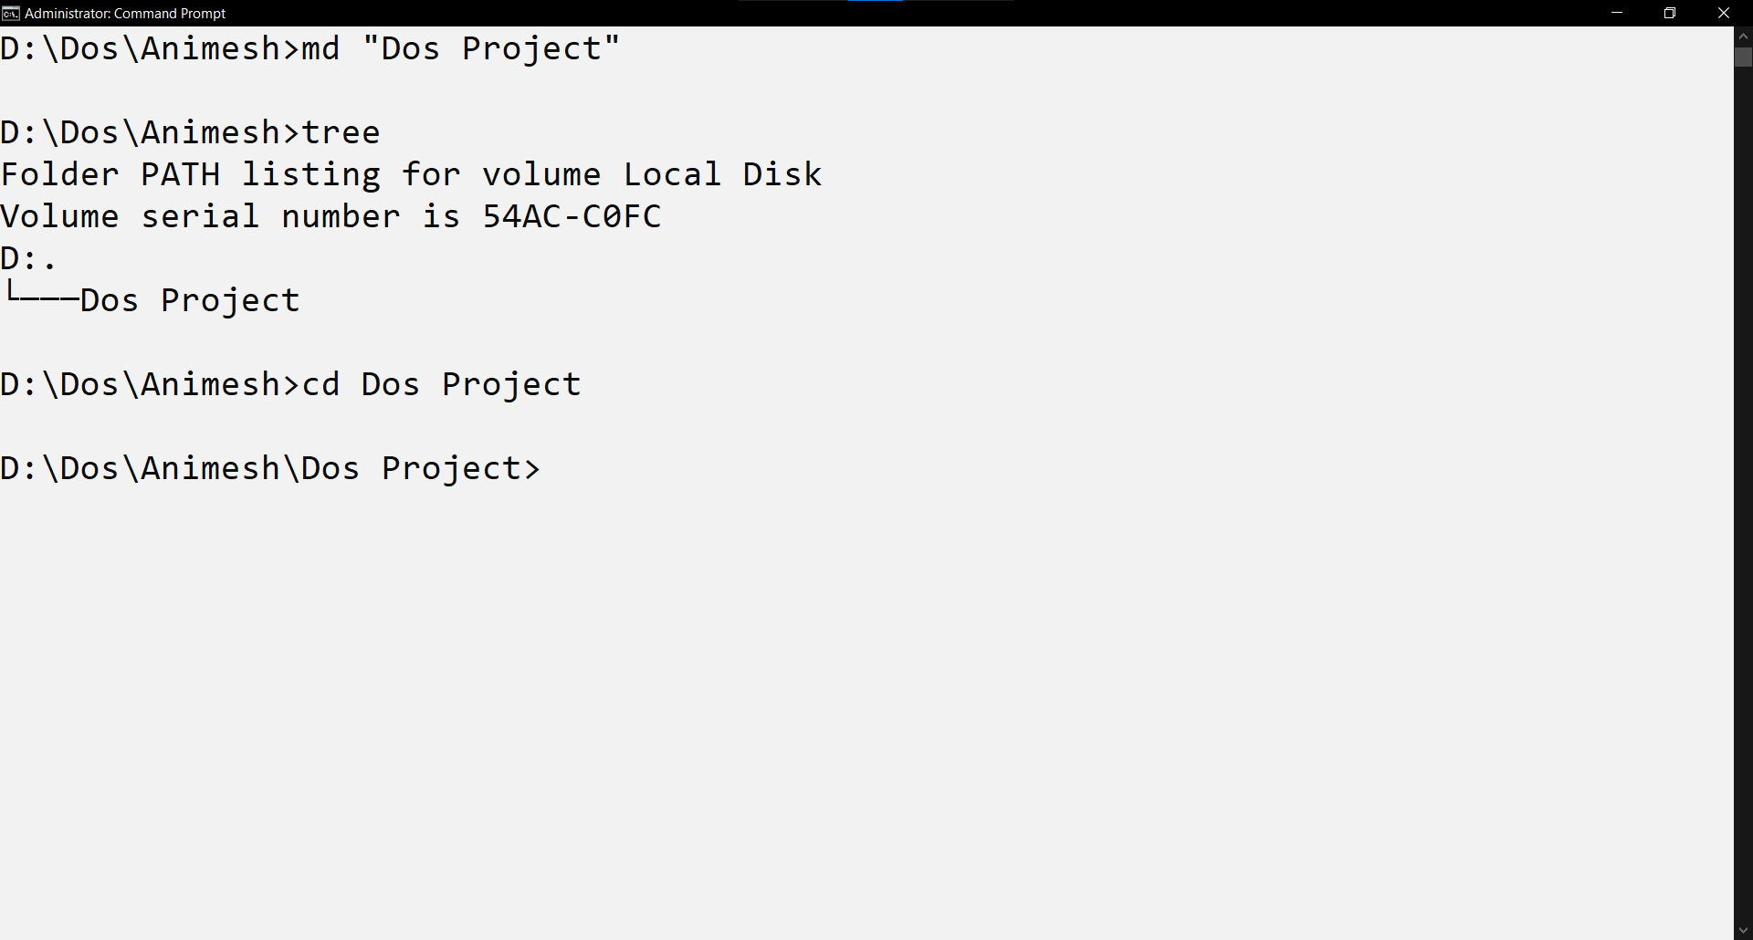**cd- To change directory of the command prompt.**

## Echo:

Echo command is used in DOS to print its own arguments back out to the DOS equivalent of the standard output stream. (Hence the name, ECHO). Usually, this means directly to the screen, but the output of echo can be redirected, like any other command, to files or devices. (Computer Hope, n.d.)

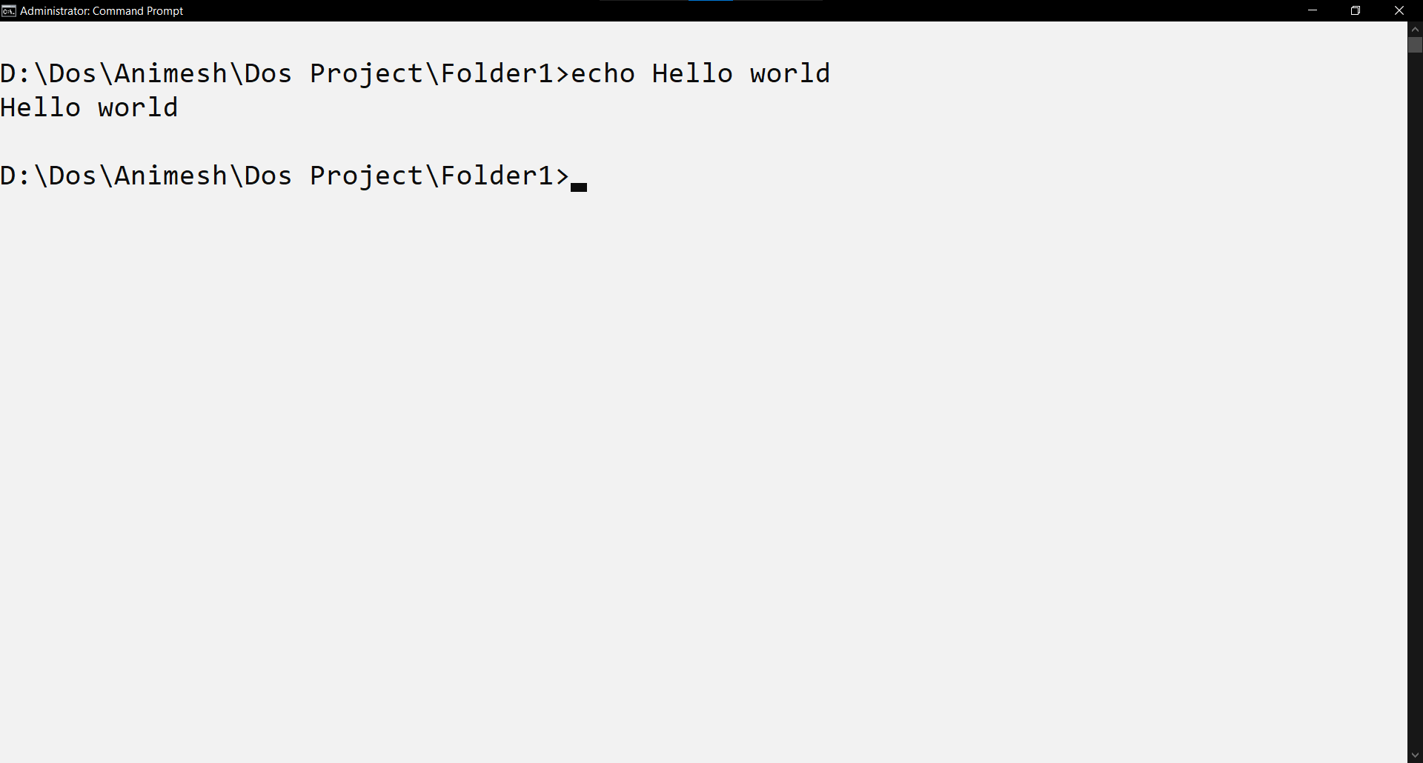Command used: **echo-Prints an argument in MS Dos window.**

## Rename:

The rename folder is used to rename a file. Unlike the move command, this command cannot be used to rename subdirectories, or rename files across drives. Mass renames can be accomplished by the used of wildcards characters asterisk (*) and question mark(?). (Computer Hope, n.d.)

Command Used**:**

1. **rename- Renames a file.**
2. 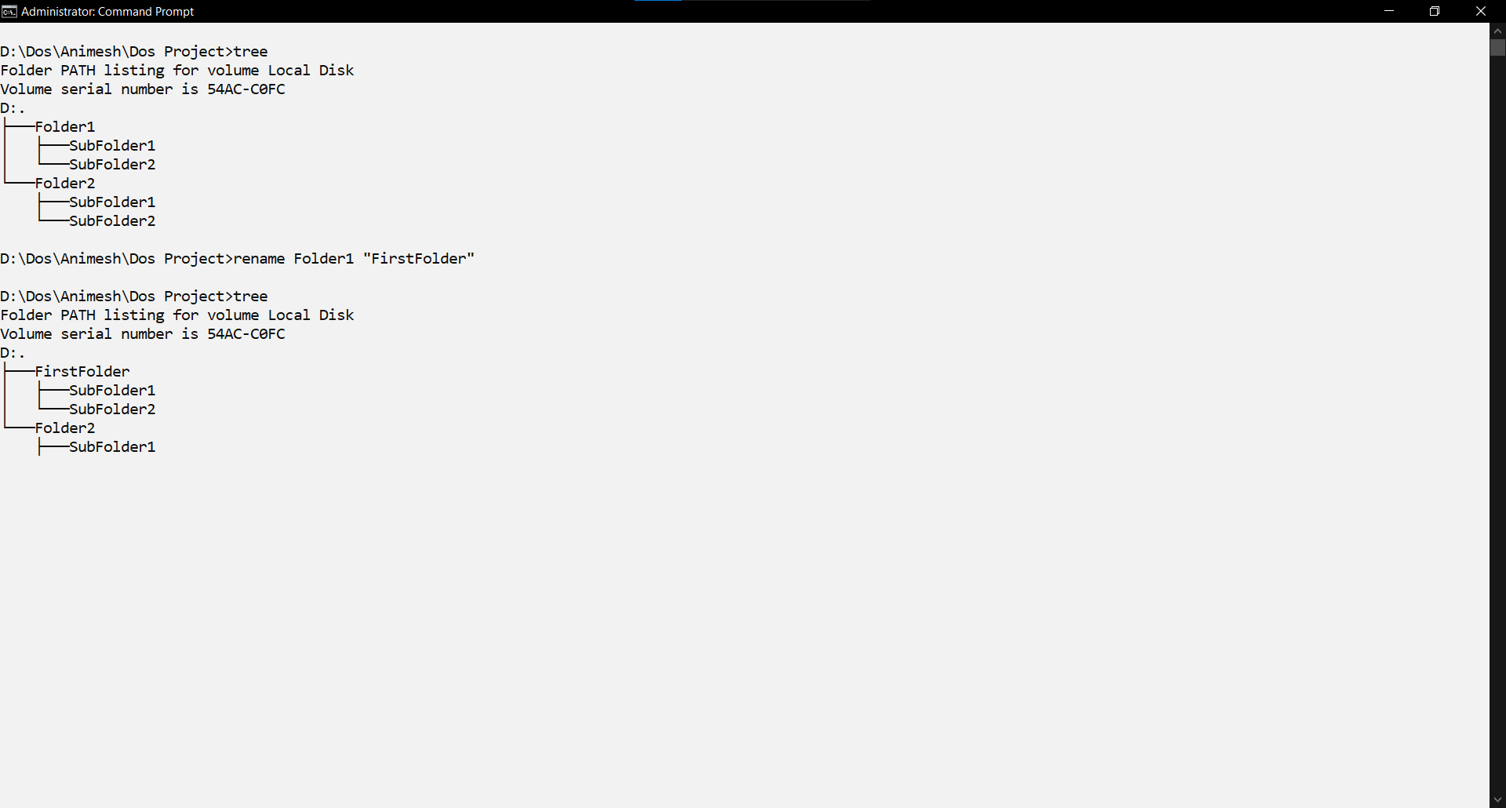**tree – Show the directory tree.**

## Copy Con/Dir:

Copy command can be used to copy a data in a file or copy a entire file. It is used to make copies of existing files. (Computer Hope, n.d.)

Command used:

1. **Copy- Copies a file.**
2. 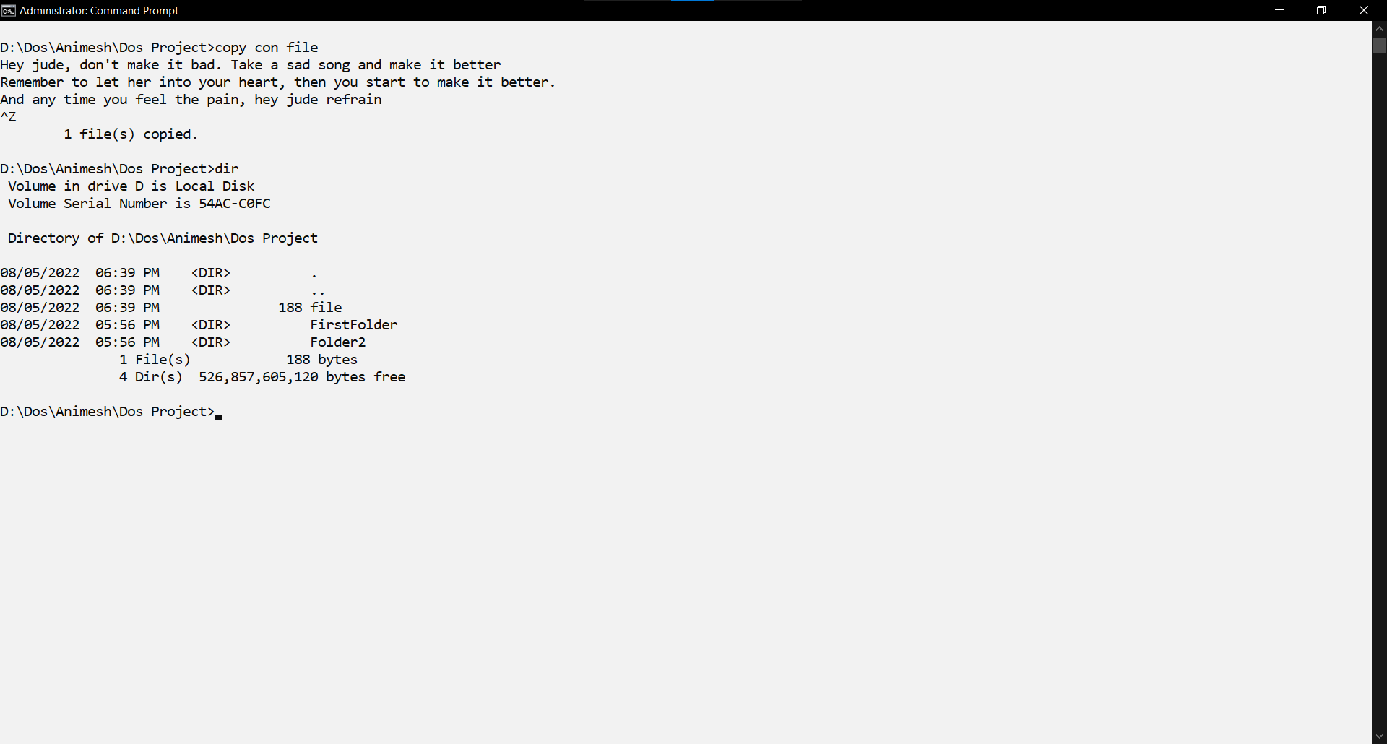**Dir- Shows the complete list of the file in the directory.**

## Type:

As the name suggest, type command can be used to type the data stored in a file. It is available in MS- Dos versions 1 and later. (Computer Hope, n.d.)

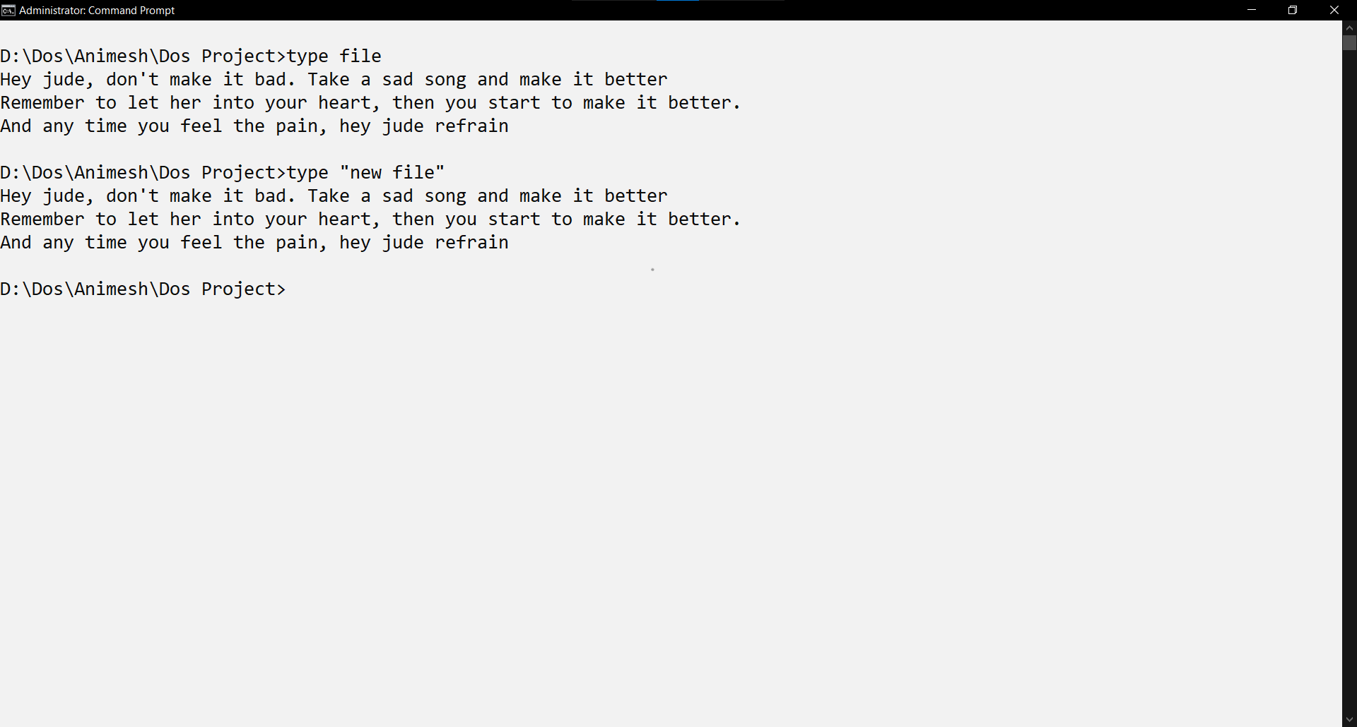Command used: **type- Types a file in the MS Dos window.**

## Del:

DEL is used to delete one or more files. The command is available in MS- DOS versions 1 and later. (Computer Hope, n.d.)

Command used: **del.**

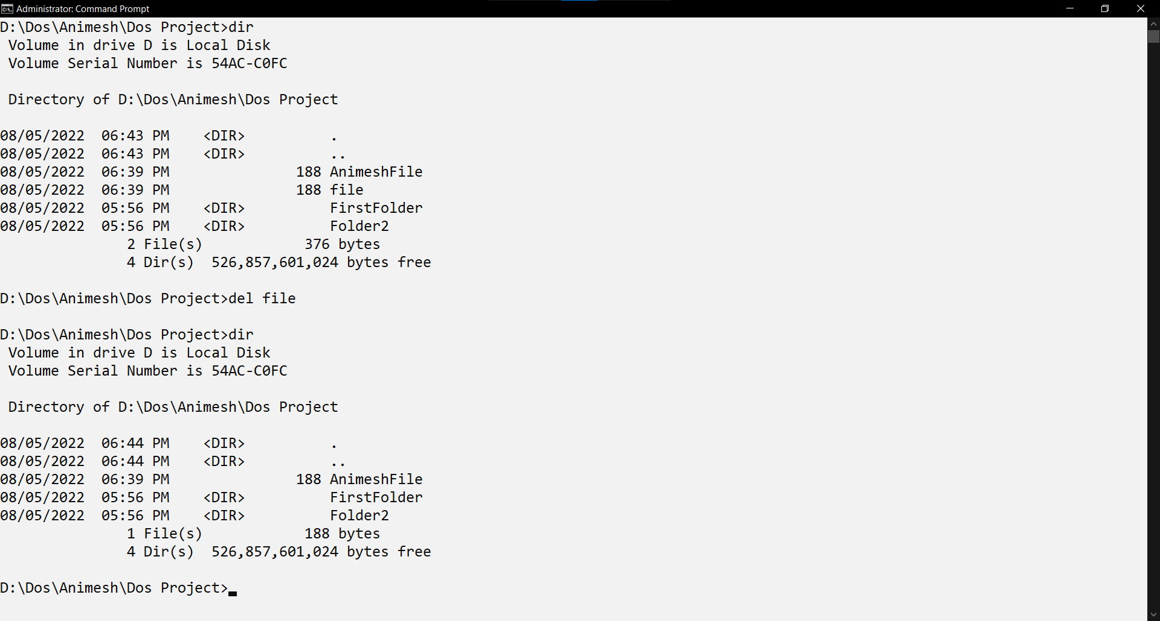

## Move:

Move command is used to move files or rename directories. The command is available in MS- DOS versions 6 and later. (Computer Hope, n.d.)

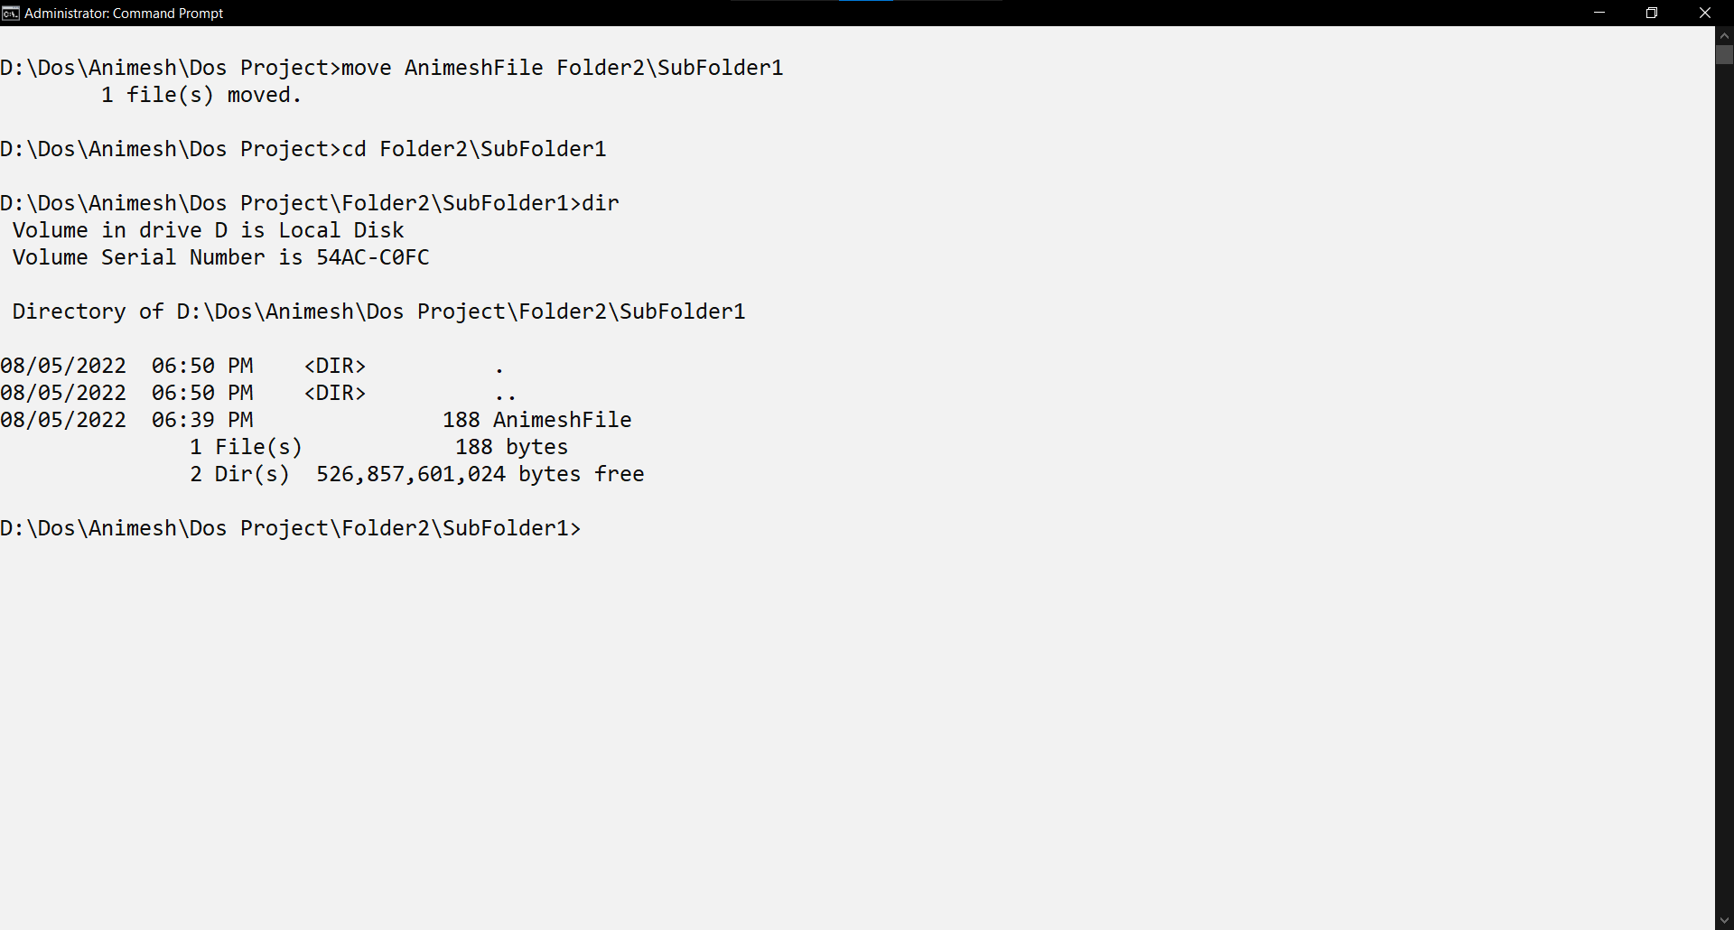Command files: **move.**

## Telnet:

Telnet is a command-line protocol for connecting to remote systems over a network. It enables text-based communication but is less secure than alternatives like SSH. It's commonly used for troubleshooting and network management.



## Tracert:

Tracert (Trace Route) is a command-line tool used in Windows operating systems to trace the route that data takes from the local computer to a specified destination IP address or hostname. It displays a list of all the routers or hops that the data packets traverse, along with the time it takes for each hop. Tracert is valuable for diagnosing network connectivity issues and identifying delays in data transmission by providing insights into the path data follows across the internet or an internal network. 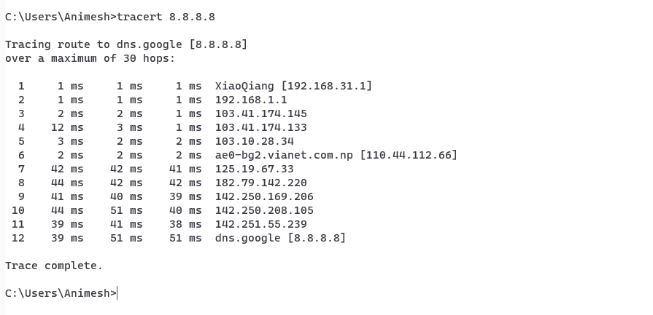

## Ping:

Ping is a command-line tool to test and measure the reachability and round-trip time of a host on a network. It's commonly used for diagnosing network issues and assessing connectivity. 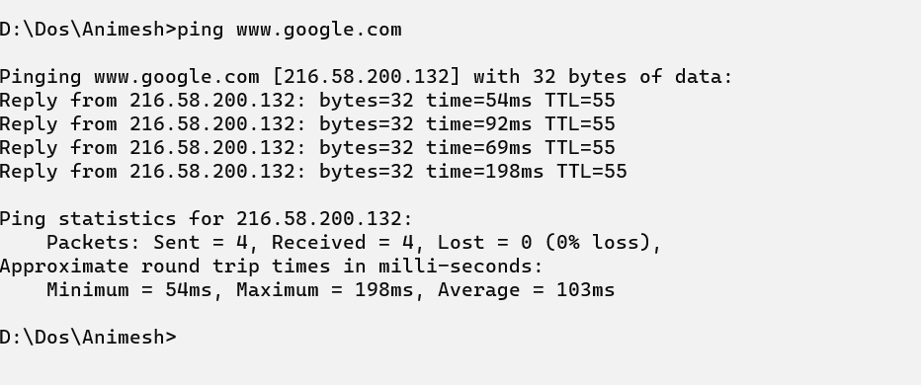

## Ipconfig:

`ipconfig` is a command-line utility in Windows used to display the configuration of the network interfaces on a computer. It provides information about the computer's IP addresses, subnet masks, default gateways, and other network-related settings. This command is essential for troubleshooting network connectivity issues, checking IP configurations, and obtaining details about the local network setup. 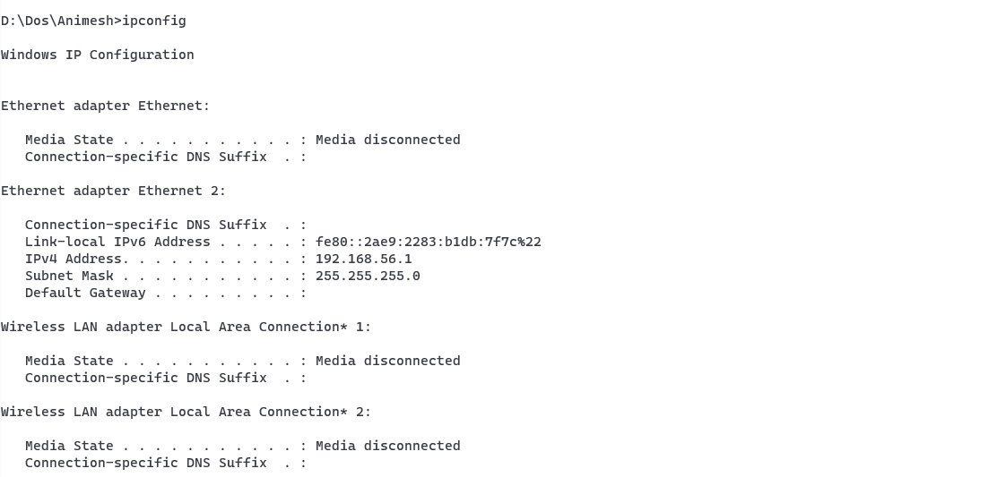

## Chkdsk:

`chkdsk` (Check Disk) is a command-line utility in Windows used to check the integrity and fix errors on a file system, typically on a hard drive or external storage device. When run with specific parameters, it can scan for and repair disk-related issues such as bad sectors, file system corruption, and logical errors. Chkdsk is often employed to ensure the stability and reliability of storage devices, and it can be particularly useful in resolving disk-related problems that may lead to data loss or system instability.

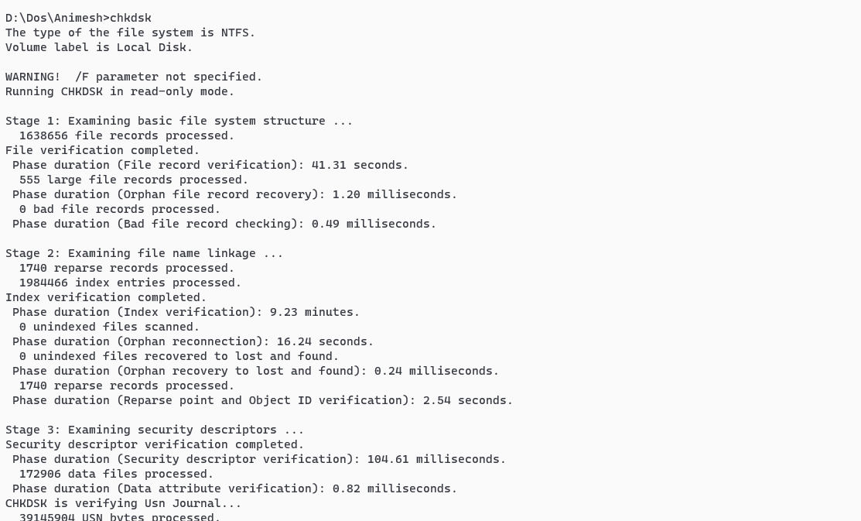

## Rmdir:

Rmdir is a Microsoft dos command used to remove a folder from the directory. (Computer Hope, n.d.)

Command used:

1. Rmdir- Removes a empty folder.
2. Tree- Show the directory tree.

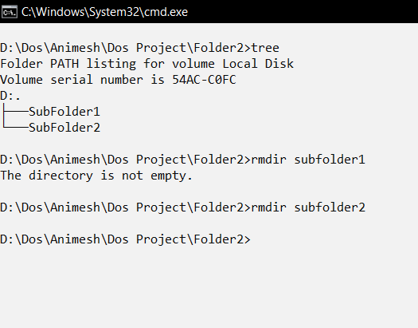

# Linux/Kali -Linux:

## Pwd

`pwd` (Print Working Directory) is a Linux command that displays the current working directory, showing the full path of the user's current location within the file system. It's a quick way to identify the directory in which you are located in the terminal.

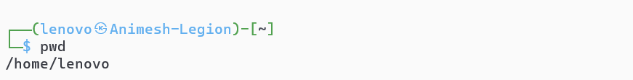

## Cd []/ cd .. / cd

1. `cd [directory]`: Changes the current working directory to the specified directory.

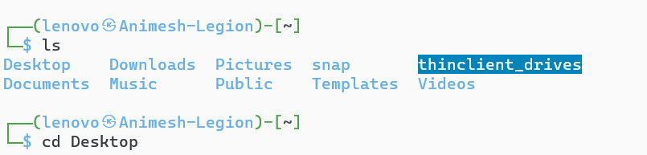

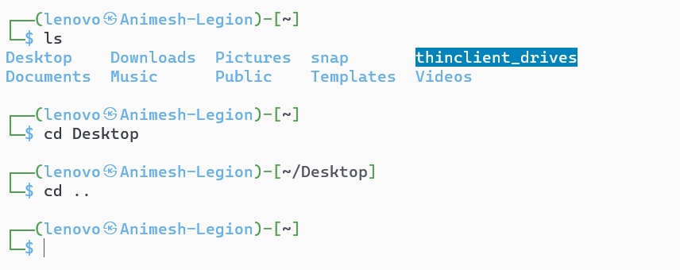2. `cd ..`: Moves up one level in the directory structure, changing the current working directory to the parent directory.

1. `cd`: Changes the current working directory to the user's home directory.

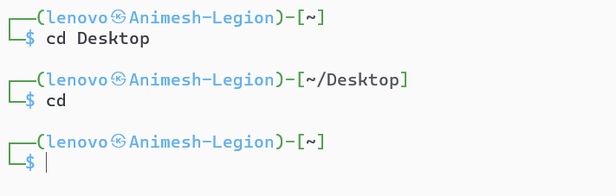

## Ls/ ls-a ls –all/ ls –R/ ls –l

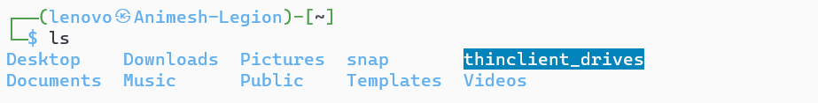1. `ls`: Lists files and directories in the current directory.

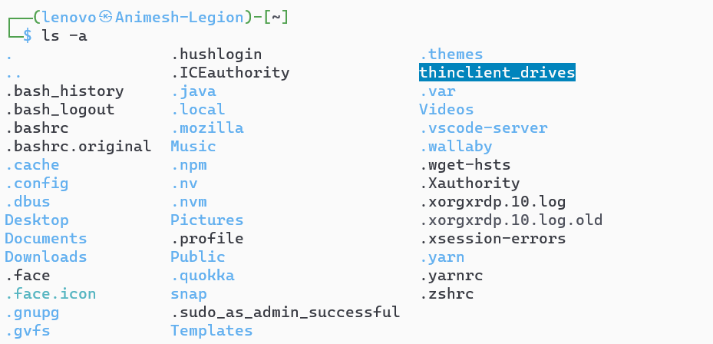2. `ls -a` or `ls --all`: Lists all files and directories, including hidden ones, in the current directory.

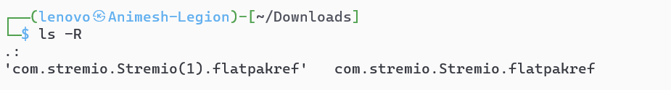3. `ls -R`: Recursively lists files and directories, including subdirectories.

1. 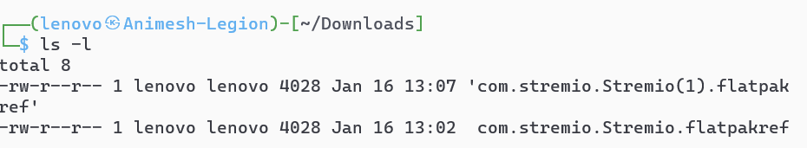`ls -l`: Displays a detailed, long-format listing, providing additional information such as permissions, owner, group, size, and modification time for each file in the current directory.

## Touch

`touch` is a Linux command used to create an empty file or update the access and modification timestamps of an existing file to the current time. It's a versatile command for file management and is commonly used in scripts and command-line operations.

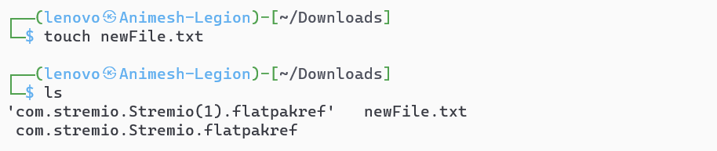

## Echo

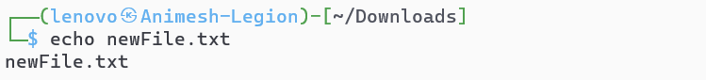`echo` is a Linux command used to display text or variables in the terminal. It's often used in scripts to print messages or output, and it can also be used for basic text manipulation and redirection.

## Cat

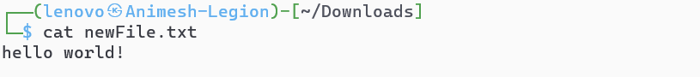`cat` (concatenate) is a Linux command used to display the contents of a file or concatenate multiple files and display the output. It's frequently used for viewing file contents, combining files, or creating new ones.

## Cp

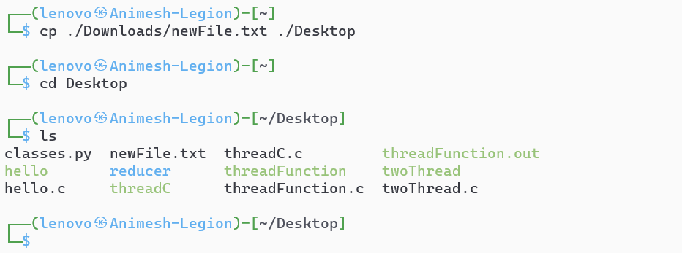`cp` is a Linux command used to copy files or directories from one location to another. It is a fundamental command for file management, allowing users to duplicate files and directories with various options for customization.

## Mkdir

`mkdir` is a Linux command used to create a new directory (folder) with the specified name. It is an essential command for organizing files and creating directory structures in the file system.

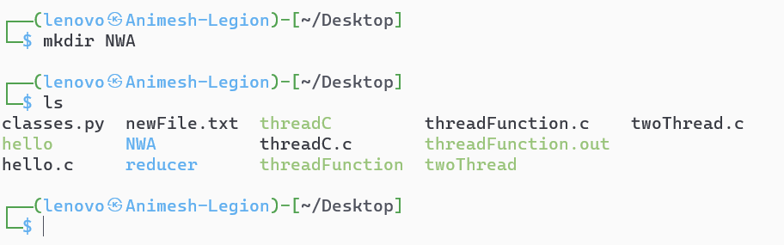

## Rmdir

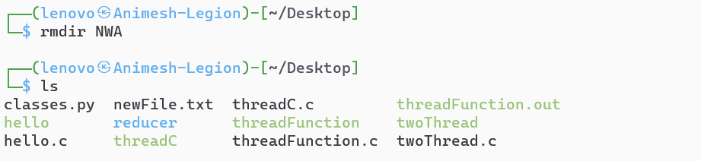`rmdir` is a Linux command used to remove an empty directory. It deletes the specified directory only if it is empty; otherwise, it returns an error. For removing directories with content, the `rm -r` command is typically used.

## Sudo

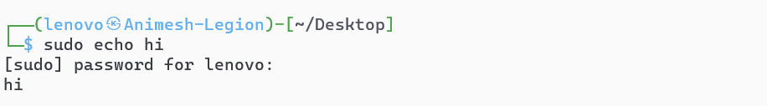`sudo` is a Linux command that stands for "Superuser Do." It is used to execute commands with elevated privileges, usually requiring authentication with the user's password. This command is crucial for performing administrative tasks and actions that require root or superuser permissions.

## Df/du

1. 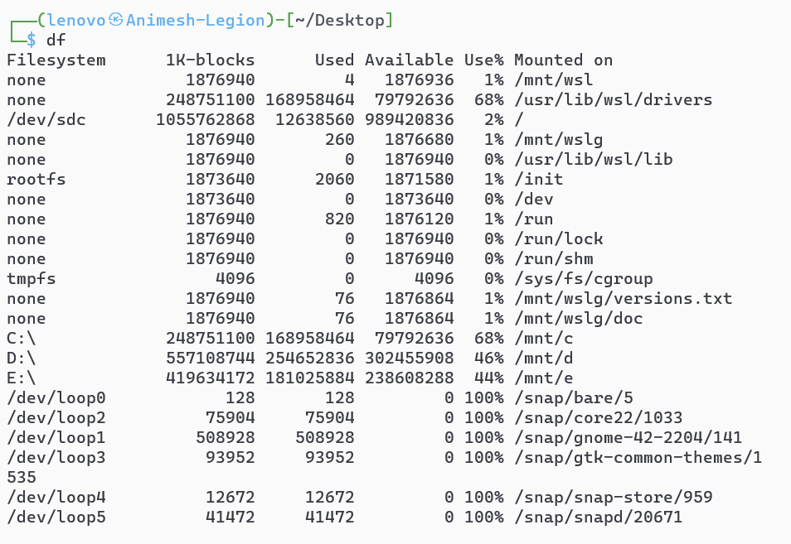`df`: The `df` command in Linux is used to display information about disk space usage on mounted file systems. It shows details such as total space, used space, available space, and the file system's percentage usage.
2. `du`: The `du` command is used to estimate and display the disk space usage of files and directories. It provides information on the size of individual files and the cumulative size of directories.

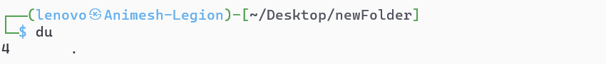

## Date/ Time

1. `date`: The `date` command in Linux is used to display the current date and time. It can also be used to set the system date and time.

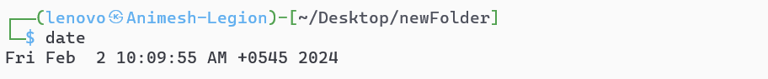

2. `time`: The `time` command is used to measure the execution time of a command or script. It provides information about the real time, user CPU time, and system CPU time consumed by the specified command.

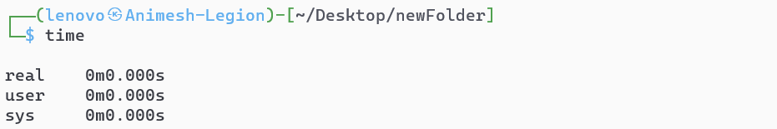

## Man / --help

1. `man`: The `man` command in Linux is used to display the manual (documentation) for a particular command or topic. It provides detailed information about command usage, options, and functionalities.



1. 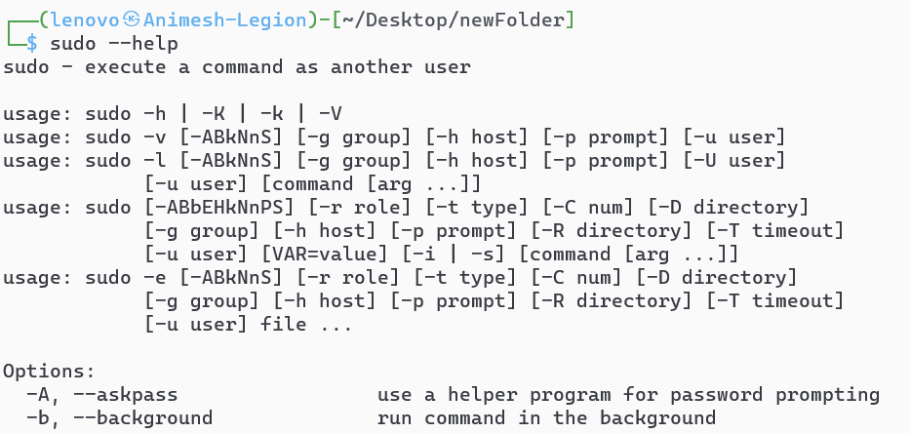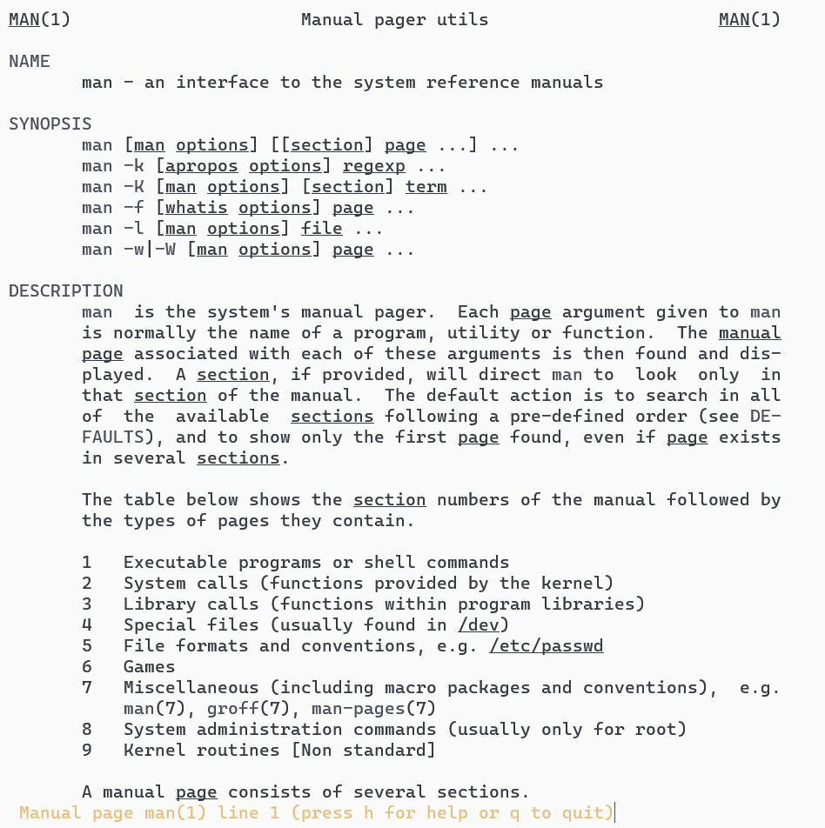`--help`: Many Linux commands support the `--help` option, which provides a brief summary of the command's usage and available options. It's a quick way to get a concise overview of a command's functionality.

## Chmod

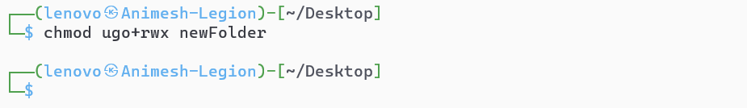`chmod` is a Linux command used to change the permissions of a file or directory. It allows users to modify the read, write, and execute permissions for the owner, group, and others. The command is crucial for controlling access to files and ensuring security in a Linux file system.

## Ping

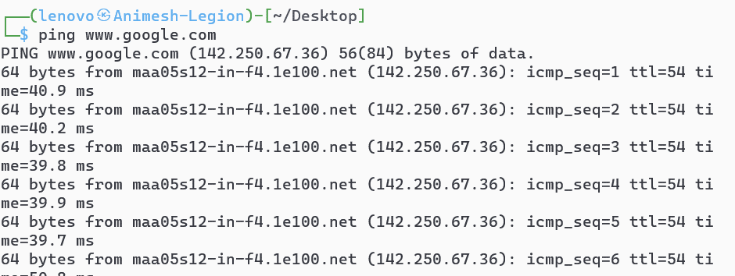`ping` is a command-line utility in Linux used to test the reachability of a host (usually a computer or server) on a network. It also measures the round-trip time it takes for data packets to travel from the source to the destination and back. `ping` is a fundamental tool for troubleshooting network connectivity issues, assessing response times, and checking the overall health of a network.

## Host

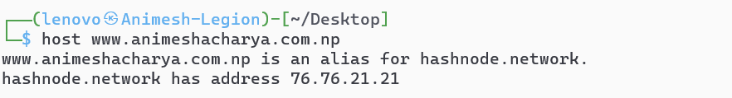The `host` command in Linux is used to perform DNS lookups and display information about domain names or IP addresses. It retrieves and displays the DNS records associated with a given domain or IP address, including information about its name servers. The `host` command is useful for resolving and verifying DNS-related information in a Linux environment.

## Ip

The `ip` command in Linux is a versatile tool for configuring and displaying network interfaces, routing tables, and other networking-related information. It provides a comprehensive set of functionalities, allowing users to manage IP addresses, network interfaces, and routing configurations. The `ip` command is a powerful replacement for older networking commands like `ifconfig` and `route`.



## Exit

The `exit` command in Linux is used to close the current shell or terminal session. When executed, it terminates the current shell process and returns the user to the previous level in the command hierarchy or closes the terminal window.

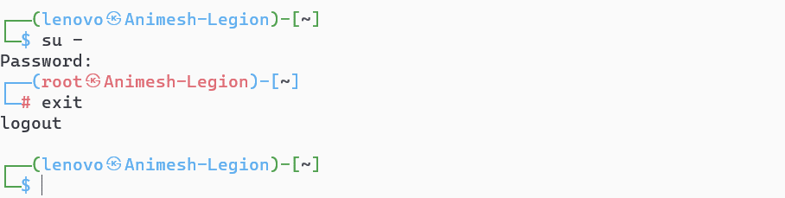

## Grep

The `grep` command in Linux is used for searching and pattern matching within text files or command output. It allows users to find and display lines containing a specified pattern or expression. `grep` is a powerful tool commonly used in conjunction with other commands and in shell scripts for text processing and analysis.



## Kill

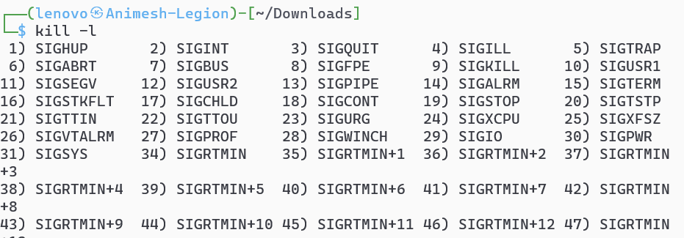The `kill` command in Linux is used to terminate or send signals to processes. It allows users to stop or control processes by sending signals, such as gracefully terminating a process (`SIGTERM`) or forcefully terminating a process (`SIGKILL`). The `kill` command is essential for managing and stopping running processes in a Linux system.

## Top

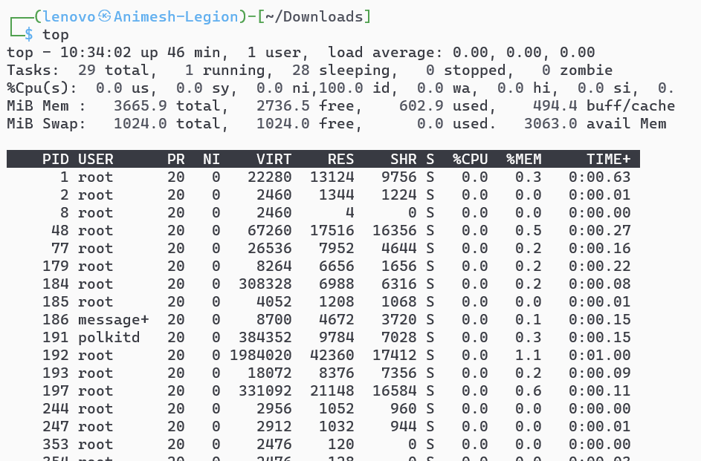The `top` command in Linux provides a dynamic, real-time overview of system resource usage. It displays a continuously updated list of processes, along with information about CPU, memory, and swap usage. `top` is a valuable tool for monitoring system performance and identifying resource-intensive processes in a terminal environment.

## Sudo apt-get install ‘package’/ Sudo apt-get remove ‘package’

1. 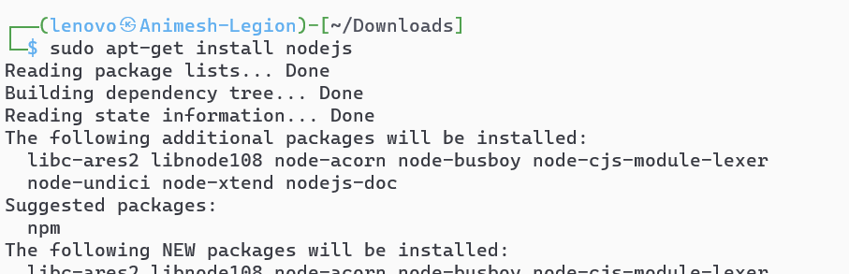`sudo apt-get install 'package'`: This Linux command is used with the Advanced Package Tool (APT) to install a specified package. It requires superuser privileges (`sudo`) to execute and downloads and installs the specified software package.
2. `sudo apt-get remove 'package'`: This command, also using APT with superuser privileges, is used to uninstall or remove a specified package from the Linux system. It removes the package and its associated configuration files.

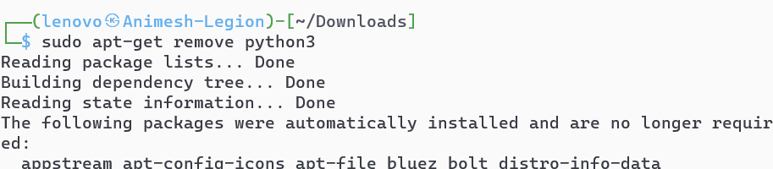

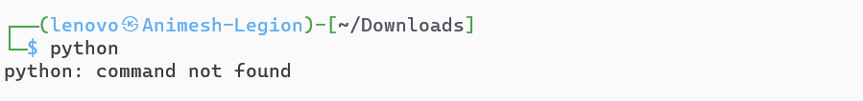

## Sudo apt-get update

`sudo apt-get update` is a Linux command used to refresh the local package database on a Debian-based system. It retrieves the latest information about available packages from the configured repositories. Running this command is a crucial step before installing or upgrading software using `apt-get` to ensure that the system has the most up-to-date package information.

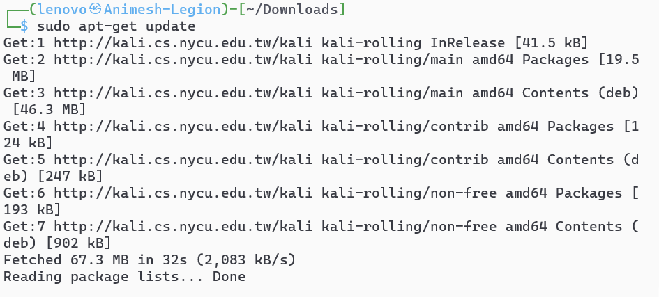

## Clear

The `clear` command in Linux is used to clear the terminal screen. When executed, it removes all previous command output, providing a clean and empty terminal window. This command does not delete any command history or affect the current state of the terminal beyond clearing the visible content.



# C program in Linux

To compile and run a simple C program in Linux, follow these steps:

1. **Write the C Program:**

Open a text editor and create a C program. For example, use a text editor like `nano` or `vim` to create a file named `hello.c`:

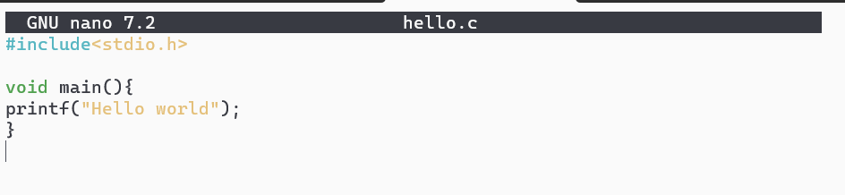

2. **Save the File:**

Save the file with the `.c` extension, such as `hello.c`.

3. **Compile the Program:**

Open a terminal and navigate to the directory containing your C file. Use the following command to compile the program:



This command uses the GNU Compiler Collection (`gcc`) to compile the C file (`hello.c`) and generate an executable named `hello`.

4. **Run the Program:**

After successful compilation, run the program with the following command. This command executes the compiled program, and you should see the output:

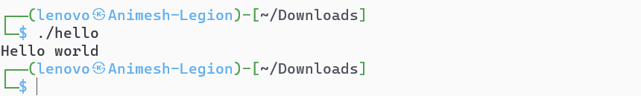

These steps assume you have the GNU Compiler Collection (`gcc`) installed on your Linux system. If not, you can install it using the package manager specific to your Linux distribution (e.g., `sudo apt-get install gcc` on Debian/Ubuntu or `sudo yum install gcc` on CentOS/RHEL).

# Process

* 1. Program to print process ID - print-pid.c
     1.  Creating the file
     2. Code:

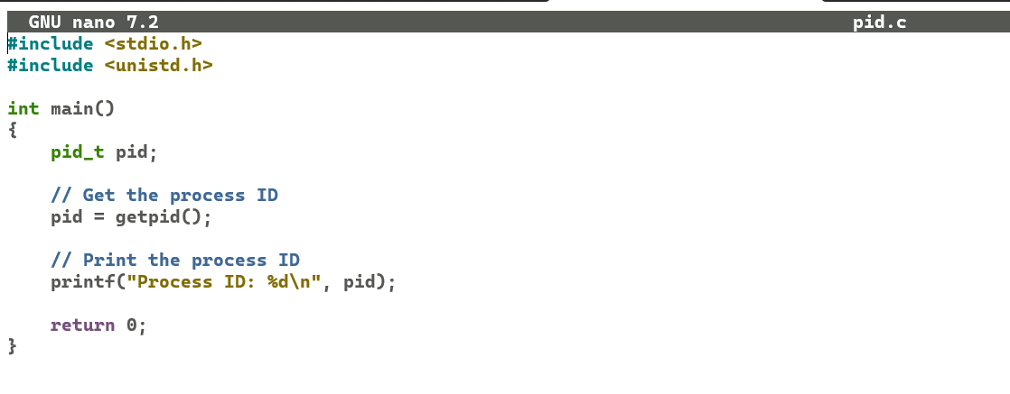

* + 1. 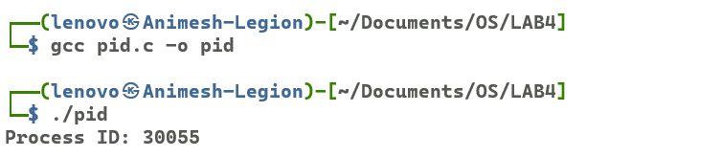Output:
    2. Top:

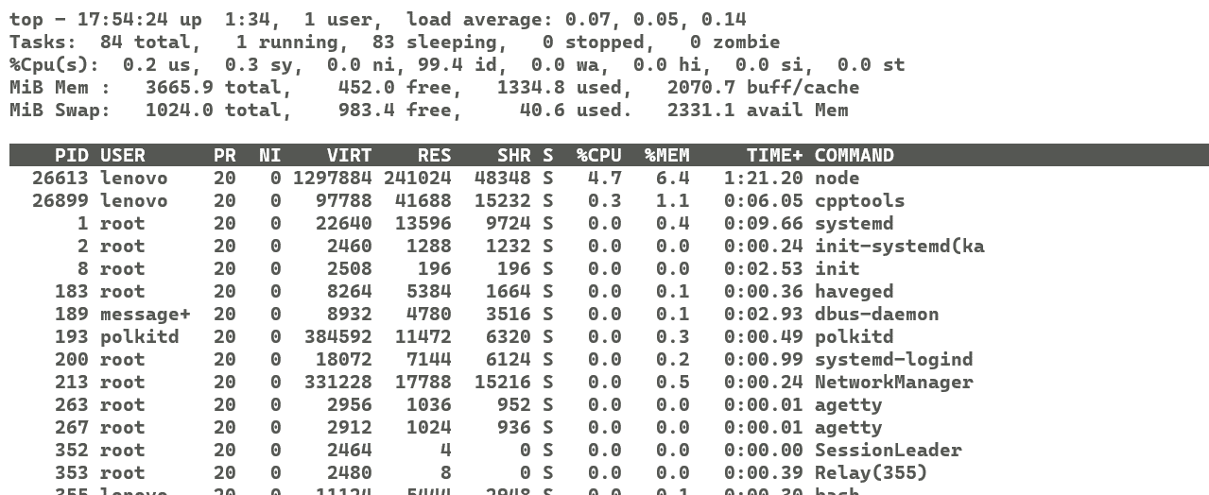

* 1. Program to create a process using system call - system.c
     1.  Creating the file
     2. Code:

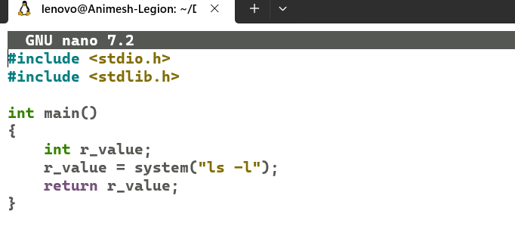

* + 1. 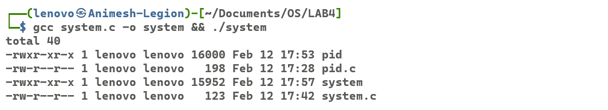 Output:
  1. Program to create a process using fork - fork.c
     1.  Creating the file:
     2. 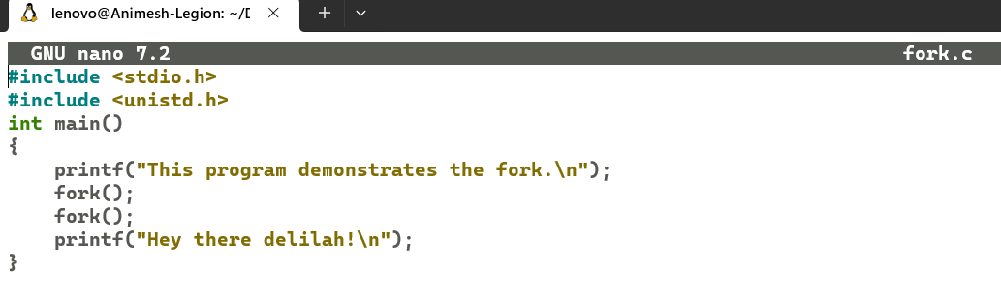 Code:
     3. 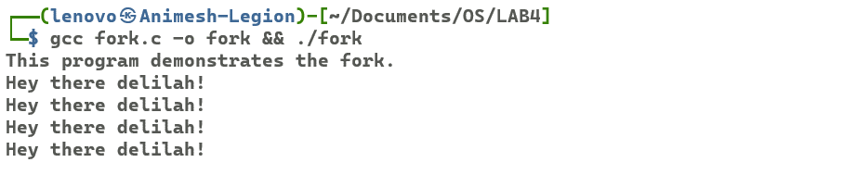 Output:
  2. Program to create process using fork and print process id - fork_2.c
     1. Creating the file:
     2. 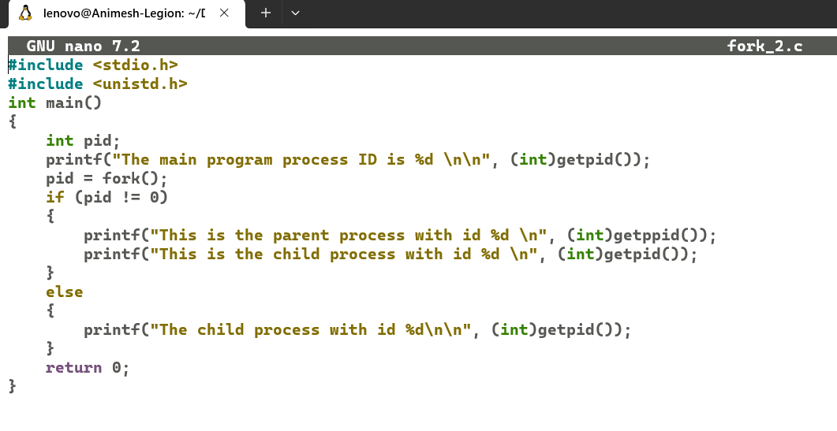 Code:
     3. 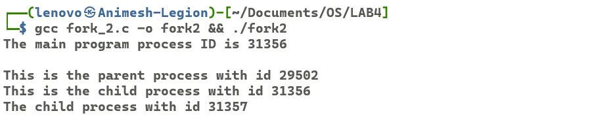 Output:
  3. Program to check the state and anlysize the output - pswitch.c
     1. Creating the file:
     2. 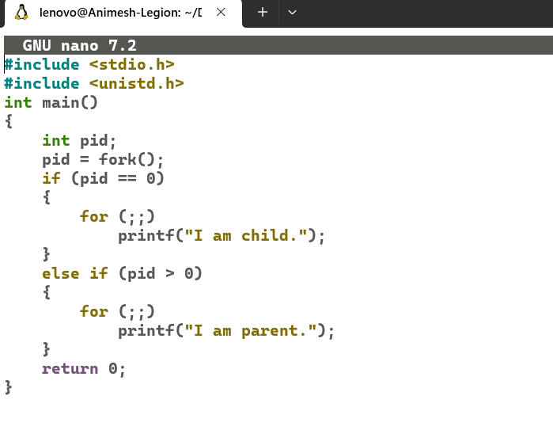 Code:
     3. Output:
  4. 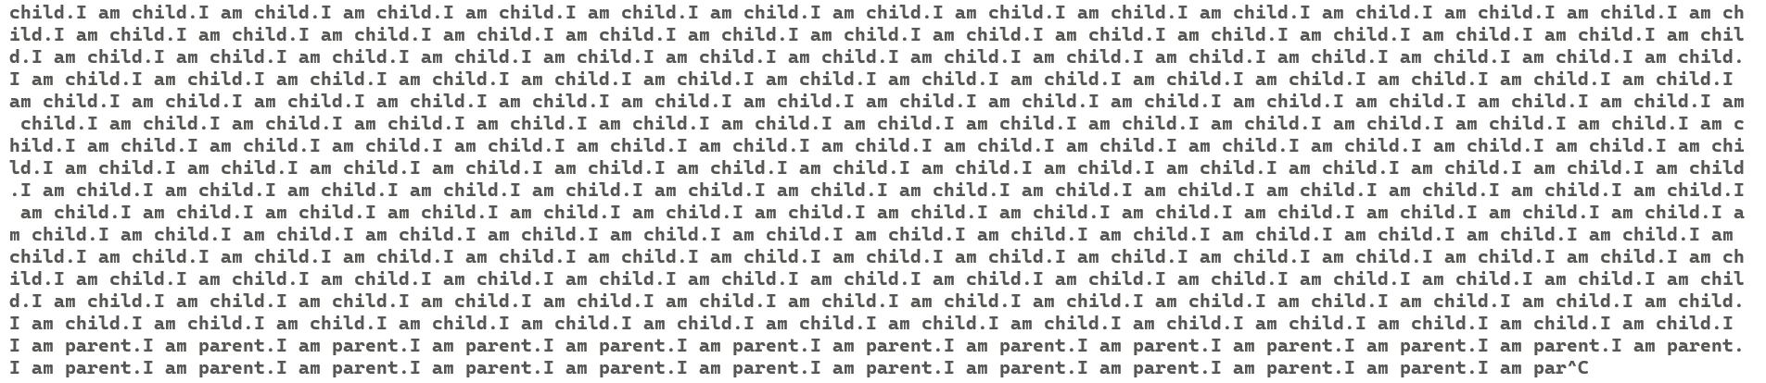Execute the program and issue the command ps -el three times in every 10 second and anlysize their output -pstat.c
     1. Creating the file:
     2. 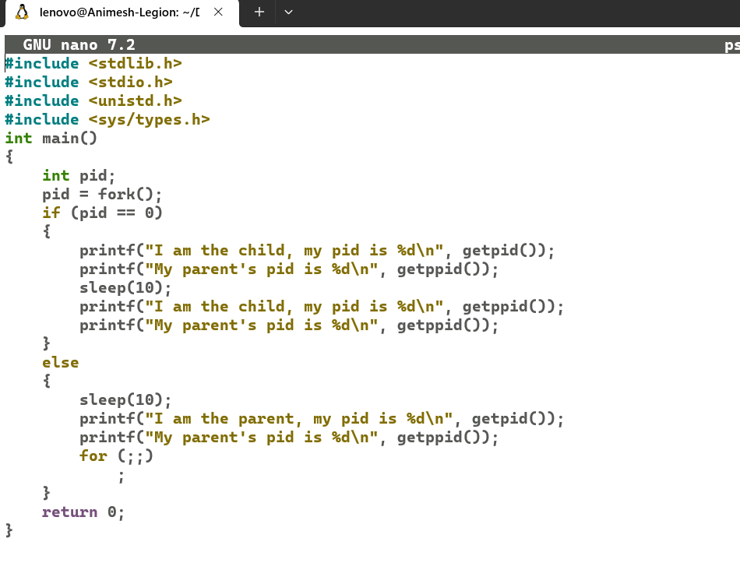 Code:

* + 1. 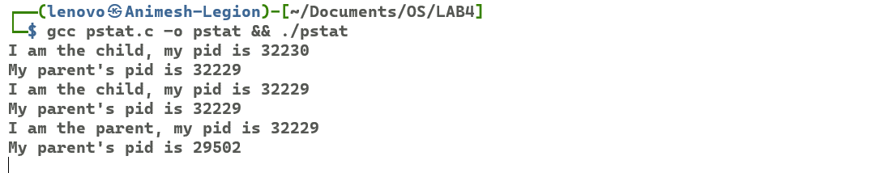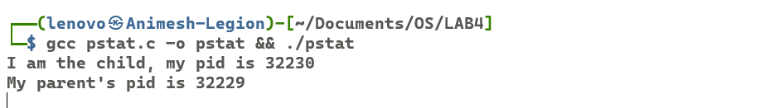 Output:

# Threads

* 1. A simple implementation of thread
     1.  Creating the file
     2. 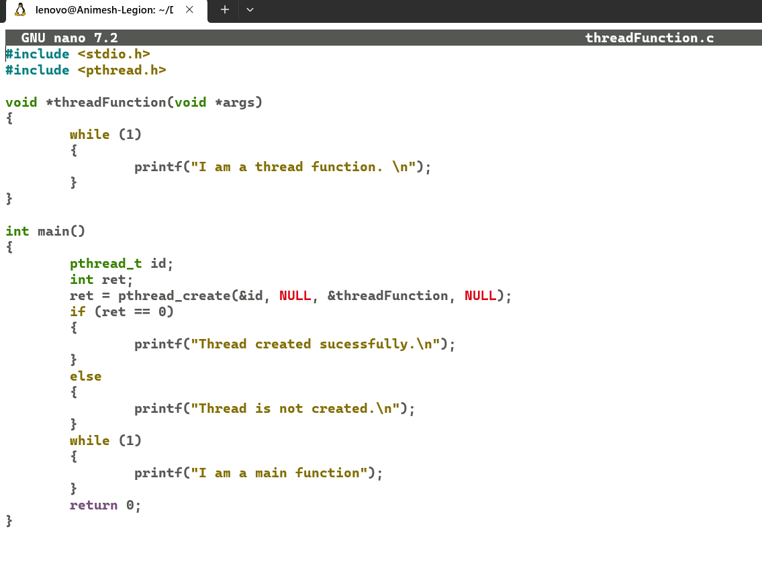 Code:
     3. 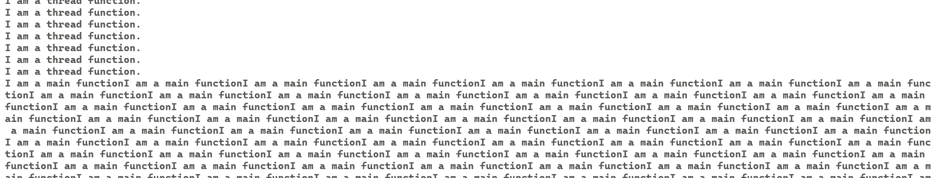 Output:
  2. Program that have two threads, one reads a word from keywords and another checks for valid word ( you can use your own word list, at least 10, to check validity)
     1. Creating the file
     2. 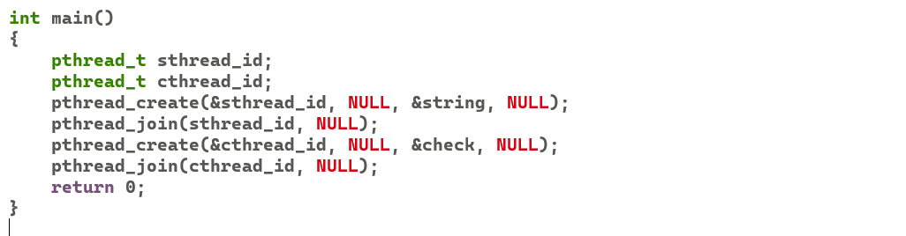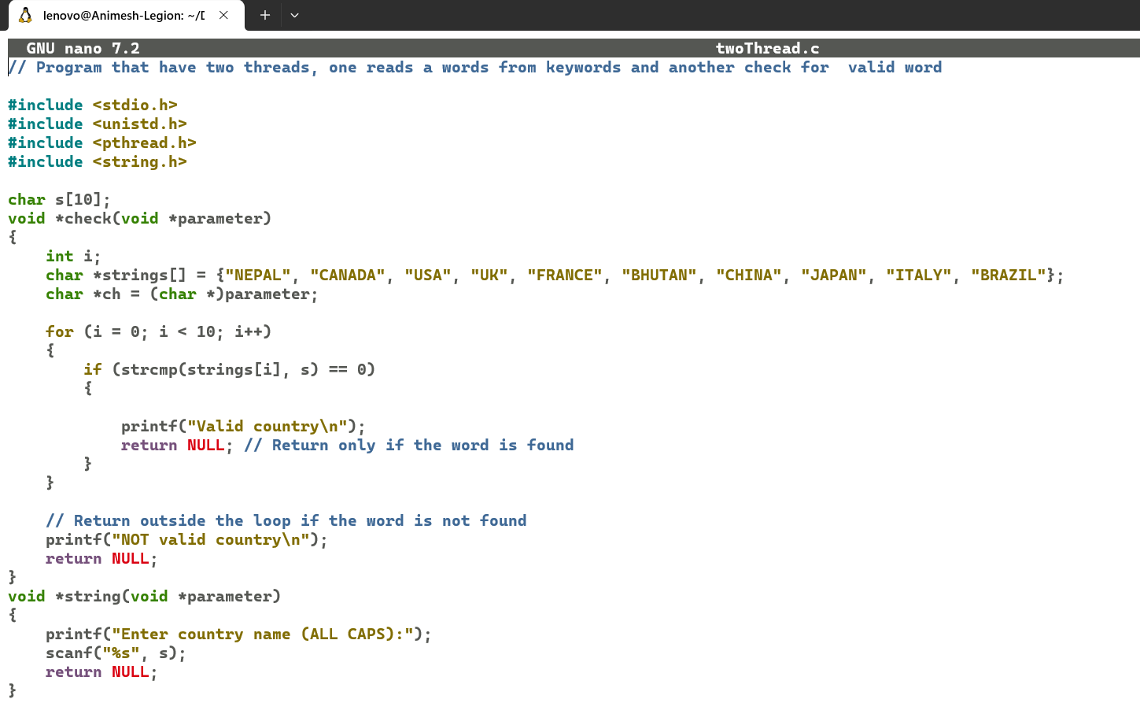 Code:
     3. 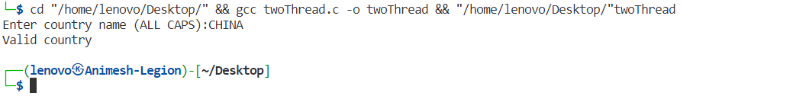 Output:
  3. Program using threads that prints sum of numbers up to given positive number n
     1. Creating the file
     2. Code: 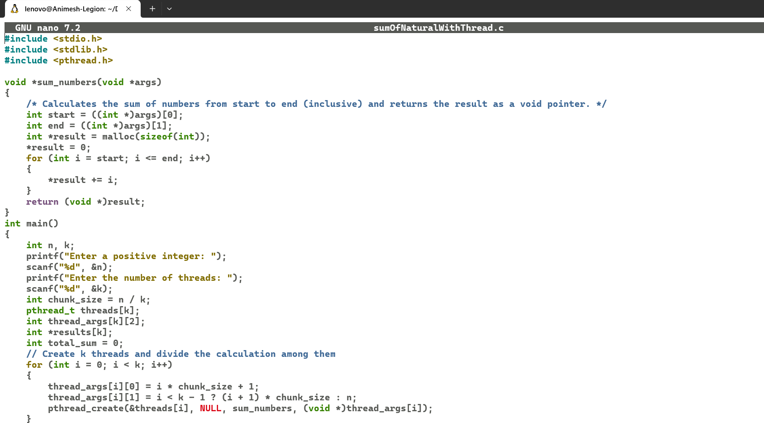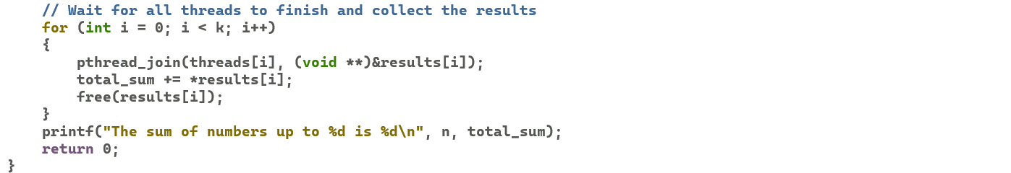
     3.  Output: